**BUG REPORTING AND TEST MANAGEMENT**

**Anita Yadav**

1. **What is bug In Software Testing?**

**Ans.** An error, flaw, failure or **fault** in a computer program or system that causes it to produce an incorrect or unexpected result.A bug is the consequence/outcome of a coding fault .

Defect accepted by development team then it is called Bug

**2. Differentiate Error, Defect, And Failure?**

**Ans Mistake** in coding is **Error.**

**Error** found by tester is **Defect.**

**Defect** accepted by Developers/Developer Team is **Bug.**

**Product** does not meet the stakeholders requirement is a **Failure.**

**3.What Are The Different Types Of Status Of Defects?**

**Ans. Different status of Bug are:**

**New:** When a defect is logged and posted for the first time. It’s state is given as new.

**Assigned:** When the tester assigns the bug to developer its status changes to “assigned”

**Open:** At this state the developer has started analyzing and working on the defect fix.

**Fixed:** When developer makes necessary code changes and verifies the changes then he/she can make bug status as ‘Fixed’ and the bug is passed to testing team.

**Pending retest:** After fixing the defect the developer has given that particular code for retesting to the tester. Here the testing is pending on the testers end. Hence its status is pending retest.

**Retest:** At this stage the tester do the retesting of the changed code which developer has given to him to check whether the defect got fixed or not.

**Verified:** The tester tests the bug again after it got fixed by the developer. If the bug is not present in the software, he approves that the bug is fixed and changes the status to “verified”.

**Reopen:** If the bug still exists even after the bug is fixed by the developer, the tester changes the status to “reopened”. The bug goes through the life cycle once again.

**Closed:** Once the bug is fixed, it is tested by the tester. If the tester feels that the bug no longer exists in the software, he changes the status of the bug to “closed”. This state means that the bug is fixed, tested and approved.

**Duplicate:** If the bug is repeated twice or the two bugs mention the same concept of the bug, then one bug status is changed to “duplicate**“.**

**Rejected:** If the developer feels that the bug is not genuine, he rejects the bug. Then the state of the bug is changed to “rejected”.

**Deferred:** The bug, changed to deferred state means the bug is expected to be fixed in next releases.

**Not a bug:** The state given as “Not a bug” if there is no change in the functionality of the application.

**4.Explain About Defect/Bug Life Cycle?**

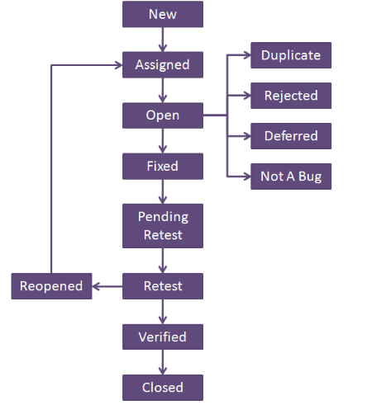

**5.A bug is identified by the tester it is assigned to whom?**

**Ans** Tester assign it to Developer

6.**Why is JIRA used? Explain step by step how an issue is created in JIRA.**

**Ans. J**IRA is a tool developed by Australian Company Atlassian. It is used for bug tracking, issue tracking, and project management.

Steps to create an issue in JIRA:

1. Click Create at the top of the screen to open the Create Issue dialog box.
2. Select the relevant Project and Issue.
3. Type in the Create Issue dialog box
4. Type a Summary for the issue and complete any appropriate fields — at least the required ones that are marked by an asterisk.
5. If you want to access fields that are not shown in this dialog box, or you want to hide existing fields:
6. Click the Configure Fields button at the top right of the screen.
7. Click Custom and select the fields you want to show or hide by selecting or clearing the relevant check boxes respectively, or click All to show all fields.
8. When you next create an issue, these selected fields will be displayed.
9. Optional: To create a series of similar issues – with the same Project and Issue Type – select the
10. Create another checkbox at the bottom of the dialog. Depending on your configuration and the values you may have specified when creating previous issues, some of the fields in the new Create Issue dialog box may be pre-populated.
11. Make sure you check they're all correct before creating the next issue.
12. When you are satisfied with the content of your issue, click the Create button.

**7.What is Defect Density?**

**Ans.Defect Density** is the number of defects confirmed in software/module during a specific period of operation or development divided by the size of the software/module.(Defect Density = Defect count/ size of the release

8.**What is the difference between defect density and defect triage?**

**Ans. Defect Density** is the number of defects confirmed in software/module during a specific period of operation or development divided by the size of the software/module.(Defect Density = Defect count/ size of the release

**Defect triage** is a process where each bug is prioritized based on its severity, frequency, risk, etc

9. **Explain Bug reporting and parameters of bug?**

**Ans .** Bug reporting is the process of reporting the bug

**Parameters of bug reporting are :**

2. Defect Id,Priority 2. Severity 3. Created by 4.Created Date 5.Assigned to

6. Resolved Date 7.Resolved By 8.Status 9.Project name 10.Product 11. name 12. Release Version 13.Module 14.Detected Build Version

10. **What is defect management? Explain the defect management process.**

**Ans.** Generally, defect management can be defined as a process of detecting bugs and fixing them. It is necessary to say that bugs occur constantly in the process of software development. Hence, every software development project requires a process that helps detect defects and fix them.

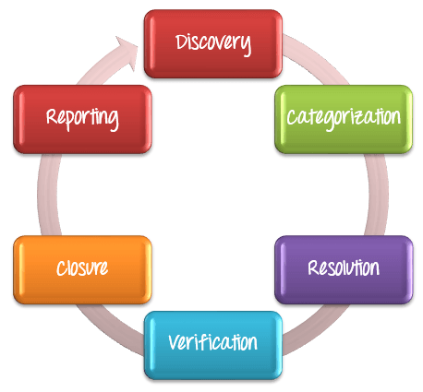

11**What is Test estimation? 1Explain Work Breakdown Structure test estimation technique with an example?**

**Ans** Test Estimation is a management activity which approximates **how long** a Task would take to complete.

In **Work Breakdown Structure test estimation** technique, a complex project is divided into modules. The modules are divided into sub-modules. Each sub-module is further divided into functionality. It means divide the whole project task into the **smallest** tasks.

12.**What is test reports? What parameters are used in test reports?**

**Ans. Test report** is a **document** which contains summary of test activities and final **test** results.It is an **assessment** of how well the Testing is performed. Based on the test report, the stakeholders can evaluate the **quality** of the tested product.

13.**What are the test management tools?**

**Ans.** JIRA and TESTLINK are test management tools

**TestLink:**

Test-link is most widely used web based open source test management tool.

It synchronizes both requirements specification and test specification together.

User can create test project and document test cases using this tool.

**JIRA**

Jira is a proprietary issue tracking product developed by Atlassian which allows bug tracking and agile project management.

It **is** used for bug tracking, issue tracking, and project management

14 .**What is a test link? How do you write test cases in TestLink?**

**Ans.**Test-link is most widely used web based open source test management tool.

It synchronizes both requirements specification and test specification together.

**To write test cases in TestLink**

Create a Test Project

Create a Test Plan

click on Test Plan Management from home-page >> at the bottom of the page click on a tab "Create" >> Fill out all the necessary information like name, description, create from existing test plan, etc. in the open window, and click on "create tab"

Build Creation

Click on Builds/Releases under Test Plan from the home page

Creating Testsuite

Click on test specification option from the home page.

On the right-hand side of the panel, click on the setting. It will display a series of test operation.

Click on the "create" tab for the test suite

Fill-up all the details for test-suite and click on save it tab.

Enter the test suite name

Enter the details about your test suite

Click on save button to save the details of test-suite

Creating a Testcase

Click on the test suite folder on the left side of the panel under a folder tree structure.

Click on the setting icon in the right side panel. List of test case operations will be displayed on the right side panel.

New window will open, to create test cases click on create a button in test-case operations.

14. **Explain steps how to upload Test case sheet on TestLink?**

**Ans.**Step 1 − To import test cases, go to Test Specifications → Test Specification from the dashboard.

Step 2 − Select the nearest test suite folders, where the test cases should be imported.

Step 3 − Click the Actions icon on the right pane.

It displays Test Case Operations.

Step 4 − Click the Import icon

Step 5 - Select the file and upload it.

Step 6 - Click the Upload file button.

15. **What is severity and priority in bug/defect?**

**Ans Severity** is defined as the degree of impact a Defect has on the development or operation of a component application being tested.

**Priority** is defined as the order in which a defect should be fixed.

16.**While placing an order for clothing website, in order confirmation page there is a logo error. It is a?**

**a)High priority, high severity**

**b)Low severity low priority**

**c)Low severity, high priority**

**d)High severity low priority**

**Ans.** c)Low severity, high priority (of low severity as it not going to affect the functionality of the website but can be of high priority as you don't want any further shipment to proceed with the wrong logo.)

18 .**While placing an order for clothing website, in order confirmation page there is a logo error. It is a?**

**a)High priority, high severity**

**b)Low severity low priority**

**c)Low severity, high priority**

**d)High severity low priority**

**Ans.** c)Low severity, high priority (of low severity as it not going to affect the functionality of the website but can be of high priority as you don't want any further shipment to proceed with the wrong logo.)

19.**Website home page failed to load.**

**a)High priority, high severity**

**b) Low severity low priority**

**c) Low severity, high priority**

**d) High severity low priority**

**Ans.** a)High priority, high severity (Major functionality failure like log in is not working, crashes in the basic workflow of the software are the best example of High Priority and High Severity)

20.**The application works perfectly for 50k sessions but beings to crash after a higher number of sessions.**

**a)Low severity low priority**

**b)High priority, high severity**

**c)Low severity, high priority**

**d)High severity low priority**

**Ans** d)High severity low priority (This problem needs to be fixed but not immediately.)

21.**Find bugs and report the same on JIRA for below-mentioned modules in the website: URL : http://www.rushplace.com/ :**

**1.My Account**

**2. Add to basket**

**3.Search**

**4.Homepage**

**Ans.** [**http://jira.tothenew.com/browse/QB-106**](http://jira.tothenew.com/browse/QB-106)

**22. Find bugs and report the same on JIRA for below-mentioned modules in the website: URL: http://newtours.demoaut.com/mercurywelcome.php : Testwebsite2**

**1.Join Now**

**2.Top header navigation options**

**3.UI bugs for the complete website.**

**Ans. http://jira.tothenew.com/browse/QB-113**

23. **Write Test Cases for Amazon login, Sign up and Forgot password on TestLink.**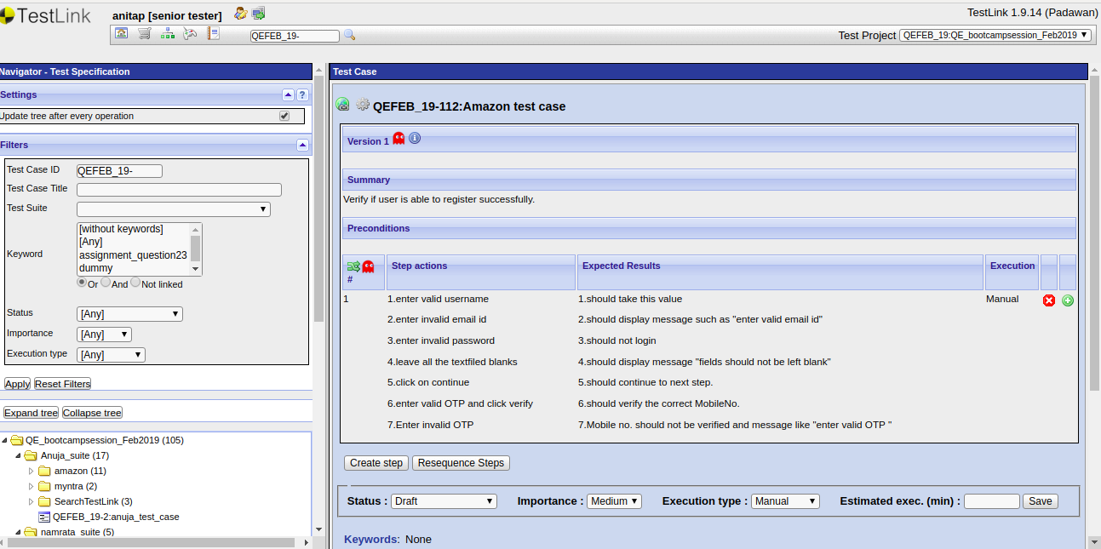

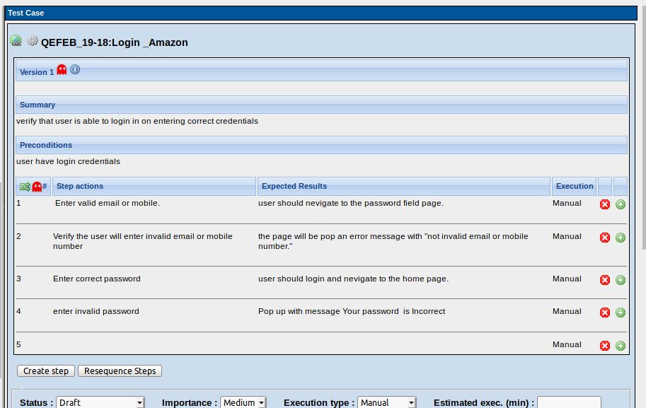

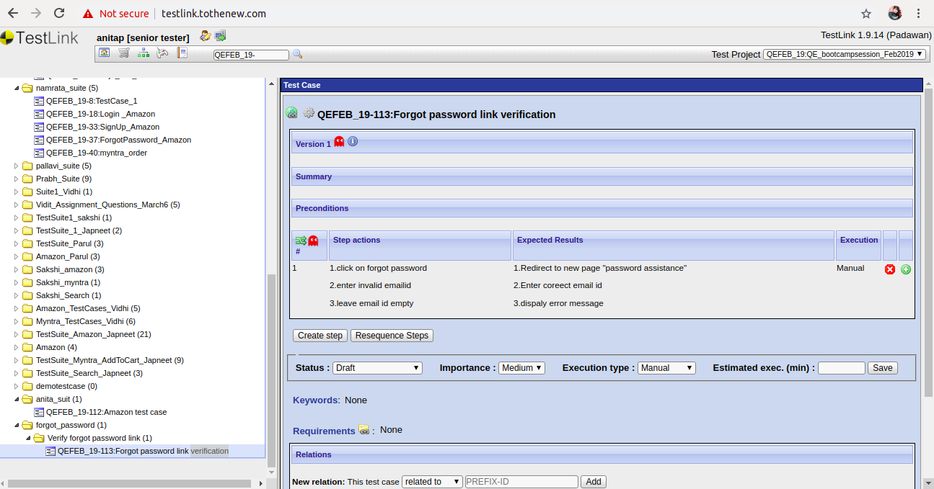

**24.Write Test Cases for placing an order in Myntra on TestLink.**

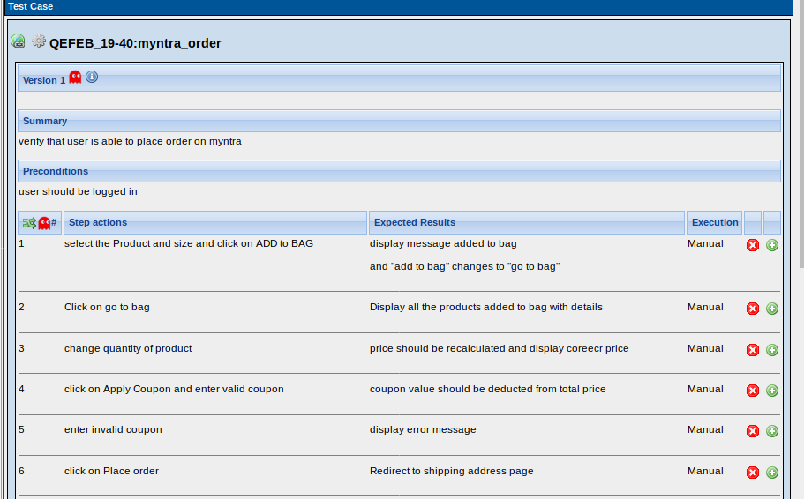

**25. Write Test Cases for Search functionality on TestLink.**

